<<[WORKSHOP|TUTORIAL]>>

<< TITLE >>

21st International Conference on

INFORMATION SYSTEMS FOR CRISIS RESPONSE AND MANAGEMENT

“Theme: Embracing the Crisis Management Lifecycle”

Conference May 25th-29th, 2024

Münster - Germany
University of Münster and State Fire Service Institute North Rhine-Westphalia
https://iscram2024.ercis.org/

TITLE

Provide a brief title for the workshop or tutorial.

ABSTRACT

Provide a brief description (no more than 500 words) of the context of the workshop or tutorial, its purpose, target audience, approach, and expected outcomes.

PRESENTER/DEMONSTRATOR

Shortly state the previous experience of the presenter(s) at ISCRAM or related meetings, and any other qualifications for this responsibility, such as recent papers on the topic you propose or experience in using the tools or procedures you want to use within the workshop or tutorial. In addition, you should note which presenter plans to be at the conference.
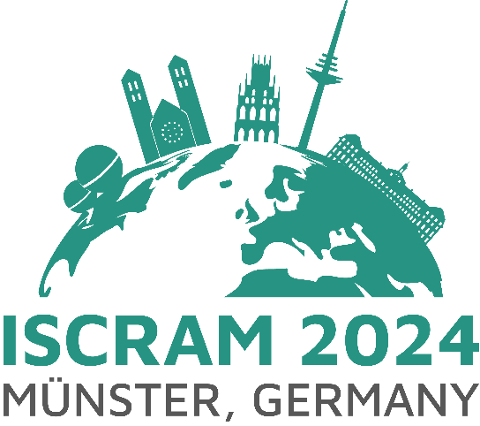
<First name and surname>*
<email address>
<Organization>

<Short info on previous experience>

<First name and surname>
<email address>
<Organization>

<Short info on previous experience>

<First name and surname>
<email address>
<Organization>

<Short info on previous experience>

*Corresponding presenter

MODE OF WORKSHOP / TUTORIAL

Please indicate which prerequisites should be met for your workshop or tutorials (e.g., technical set-up or room requirements), so the chairs can plan accordingly.

